Art gallery kiosk app documentation

# Requirements

* Implementation must use HTML/CSS with JavaScript
* Google Chrome compatibility at a minimum
* The app must feature a drawing canvas for patrons at the art gallery
* Users should be able to create artwork in the style of the artist
* Users should be able to select a brush size
* Users should be able to select a colour from the palette which is suitable to the artist’s style
* The canvas should be able to be cleared both manually by a button and automatically after a period of inactivity
* The app must be interactable with a touch screen, thus incorporate elements suitable to this type of screen
* The app must work in a responsive screen size, including 1920x1080 and 1280x720
* The app must consistently implement the artistic style and branding
* Additional drawing tools should be incorporated (eg. Stencils, stamps, patterned brush)

# Features

* Colour wheel

Colour is one of the most important elements in art. It depicts emotion and conveys meaning to the viewer. All paintings use colour in a way to make their art unique, thus is a feature that is a necessity in our kiosk. The colours can be changed in brightness to appear like the colours used by the artist.

* Brush thickness slider

The brush thickness can be used to colour in spaces quickly or set the background of your painting. Allowing the user to change thickness may be appealing to the younger audience where they favour the bigger brush.

* Brush change

Because Jasper Johns paints a lot of different kinds of abstract paintings, this was needed to suit every one of his famous paintings. The brush change is needed to draw in detail such as paint drip, which is iconic in one of Jasper Johns map paintings.

* Opacity slider

Jasper Johns loves to use add white textures in his paintings, especially in his illusion arts. The white textures tend to soften up his saturated colourful paintings, thus to create this similar effect, we will use opacity effects which adds light layers to your painting without covering it entirely.

* Stamps
  + Numbers and letters
  + Shapes
  + Flags

As we considered all his famous paintings, the most known ones include flags, numbers and maps. Adding stamps that provide numbers, letters, shapes and automated generated flags, the user can produce the same work of Jasper Johns.

* Eraser

In all canvas designs, being able to erase is a common standard. Will cause frustrating experiences for people using this kiosk if otherwise.

* Undo and Redo Button

This button helps the user if they have made a mistake. Users using this app are not meant for competition, but more for the spirit of art and creativity.

* Clear

As many users will be using this kiosk, instead of erasing all the previous work, a click of a button will solve this issue.

* Save

This will save the current drawing on the canvas. We have decided to implement this functionality as we feel it is great way to give back to the community by sharing those who put in time and effort in creating work similar to Jasper Johns.

# TARGET DEMOGRAPHIC

The expected demographic of this art gallery are people aged 8 upwards who have an interest in art by Jasper Johns. The most common users of the website are likely to be towards the younger segment of the age bracket, between 8 and 20. Therefore this will be the target demographic of the website. This target does not intend for the website to be exclusive to this audience, rather the design will be created with the intention to appeal primarily to this audience.

However, to cater for an audience who strive to mimic Jasper Johns paintings and test their art abilities, we will try to implement functionality regarding the complexity of brush strokes for those who will like to recreate or create their own ‘Jasper Johns’ art.

Also, it is important to consider the statistic of people who regularly attend art museums and art galleries. We believe that people who attend these galleries for the first time will be more likely to utilise our kiosk app, as they will be exploring as well as experimenting around in the art environment.

This assumption is evidently supported here:

<http://www.abs.gov.au/ausstats/abs@.nsf/Lookup/4172.0main+features152014>

The ABS Survey of Attendance recorded that there is a huge spike of people who throughout their lives, only attend art galleries once or twice.

## SAMPLE PERSONA:

|  |  |  |
| --- | --- | --- |
| **Persona** | School student |  |
| **Fictional name** | Hayley Johnson |
| **Job title/responsibilities** | Student at John Monash Science School |
| **Demographics** | 13 years old  Favourite subjects are art and biology  Attends painting and sculpting classes |
| **Goals and tasks** | Likes attending various art galleries  Plays volleyball and golf  Favourite art styles include abstract and pop art  Likes sketching digitally and physically |
| **Environment** | Has a Windows tablet for sketching and writing documents, is comfortable using web interfaces | |

# Jasper Johns and his art style

Jasper Johns was born in 1930 in Georgia, then later grew up in South Carolina in 1950 and finally moved over to New York to study at a University where he pursued his career as an artist. During his time as an artist he has received a ‘Medal of Freedom from Barrack Obama, a previous president of the United States.

Jasper Johns is known for a lot of abstract paintings where each are unique to their own, thus there are no specific one style that he focuses upon. Instead, rather than direct representation or abstraction, John created signs, flags and targets, the main images of his works. His inspiration focuses on “things the mind already knows” and works off that as a primary base.

In his period in the 1900’s he has paintings related to Pop art, Modern art, Neo-Dada, Abstract expressionism and some Op Art.

His most famous paintings include:

* Targets
* Maps
* Symmetry that has optical illusions
* Numbers

# Inspiration

## Jasper Johns: Target with four faces

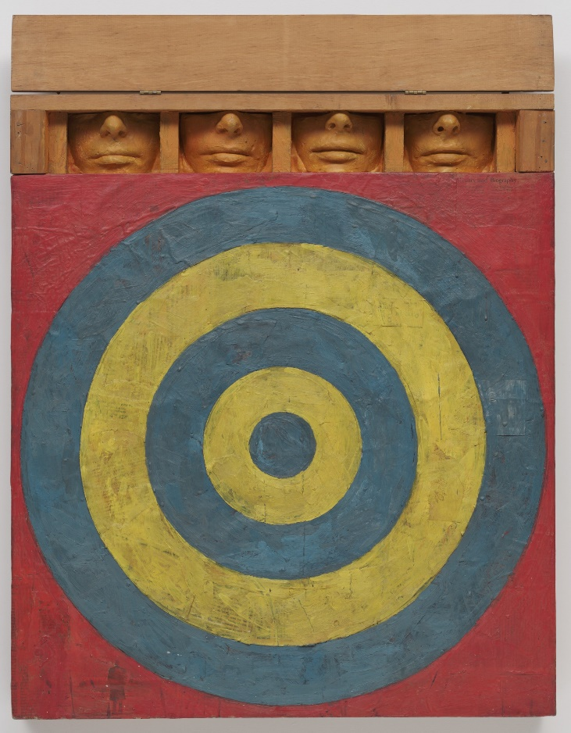

This piece in unique in a way where Jasper includes both his painting and sculpting skills. Although the sculpturing aspect is creative, I think we can ignore the 4 faces when considering aspects in our technical functionality. There are scars on the dartboard which makes the painting appear old and used.

Because of the implementation of a dartboard, we may consider shapes to form those rings. Tools that can recreate the effect of the old marks is to use a thin brush that reduces the opacity of the colour per stroke.

## Jasper Johns: Map

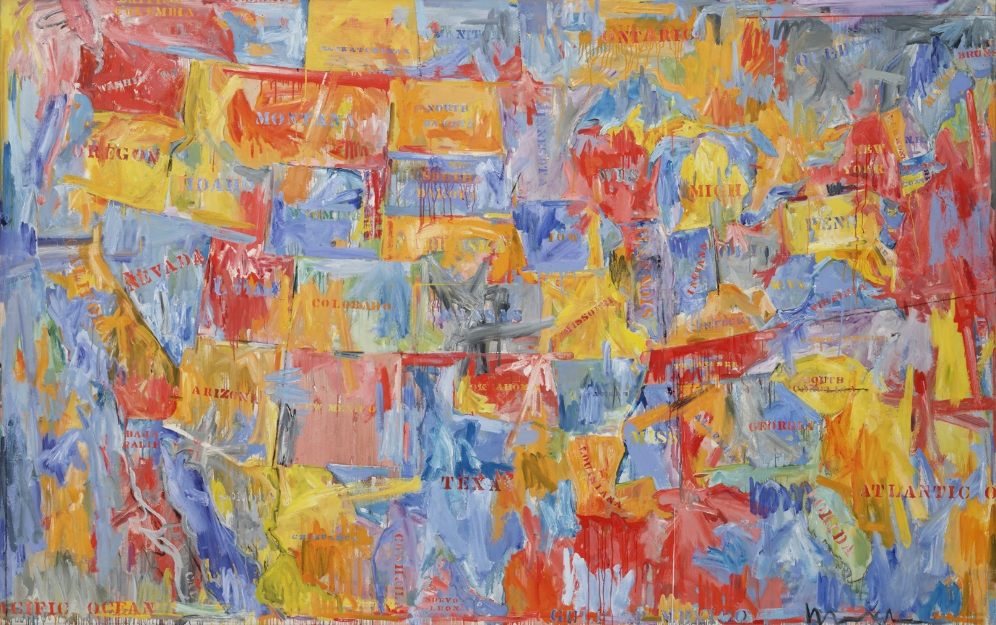

This painting “Map” has a texture called ‘dripping paint’. The text printed on the map looks like text stencils stamped onto the painting. He also uses bright colours such as red, yellow, orange and light blue.

A stamping text tool may be considered when designing our canvas. Using different brushes can solve the dripping paint texture, while also changing the thickness of the brush.

## Jasper Johns: corpse and mirror ii Jasper johns: dancers on a plane

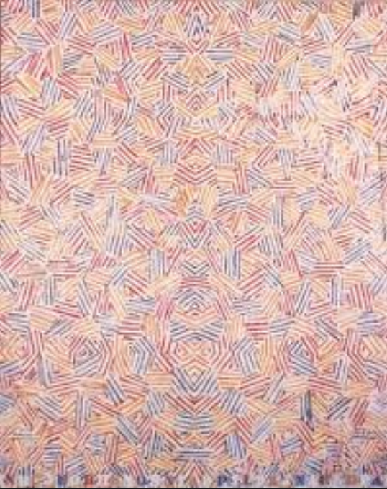

Both paintings look like the same painting, but they are not. ‘Dancers on a plane’ uses a foggy background.

Jasper sometimes uses repetition of certain patterns so that his paintings are symmetrical. With switching text colour at the bottom and his use of patterns, he uses an Op Art structure to apply an optical illusion to the viewer.

A symmetrical tool that reflects half a painting may be out of our scope and we also consider this as low priority. The foggy background for the second painting can be made by using white sprays.

The light tones in ‘dancers on a plane’ would make a nice application colour scheme which visually appeals to users.

## Jasper Johns: Land’s end

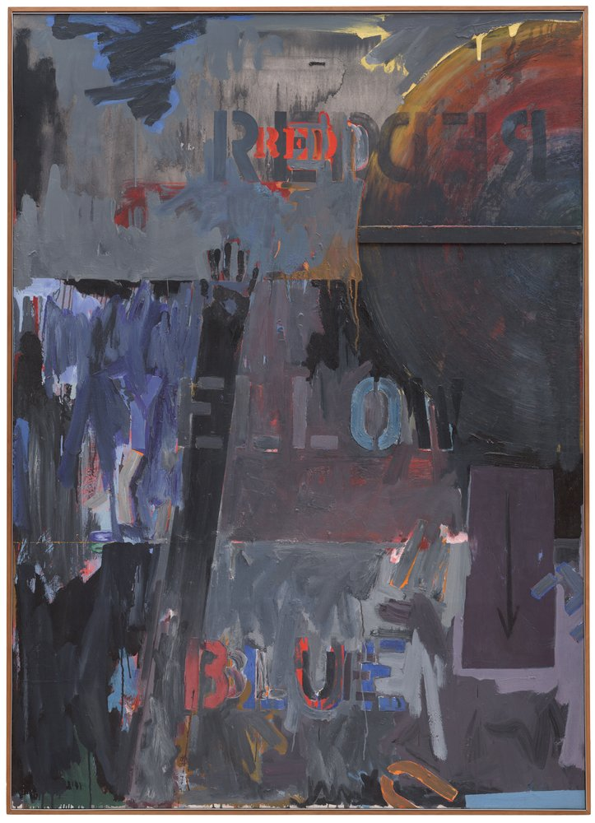

Again, here he uses similar stencils to illustrate his text. With dark colours scattered around the text, abstract items blended in, such as the hand above the word “yellow”, it implies a disturbing story to the viewer. Using the colour red and the text “red”, also depicts a sign of danger. The letter “U” at the bottom angled at the bottom, symbolising the word ‘you’ have fallen.

A lot of colours are used to overlay the grey paint, thus to recreate this effect, opacity effects will be needed for multiple layers.

Letters in this artwork can be created through stamp tools in the application.

## Jasper Johns: 0 through 9

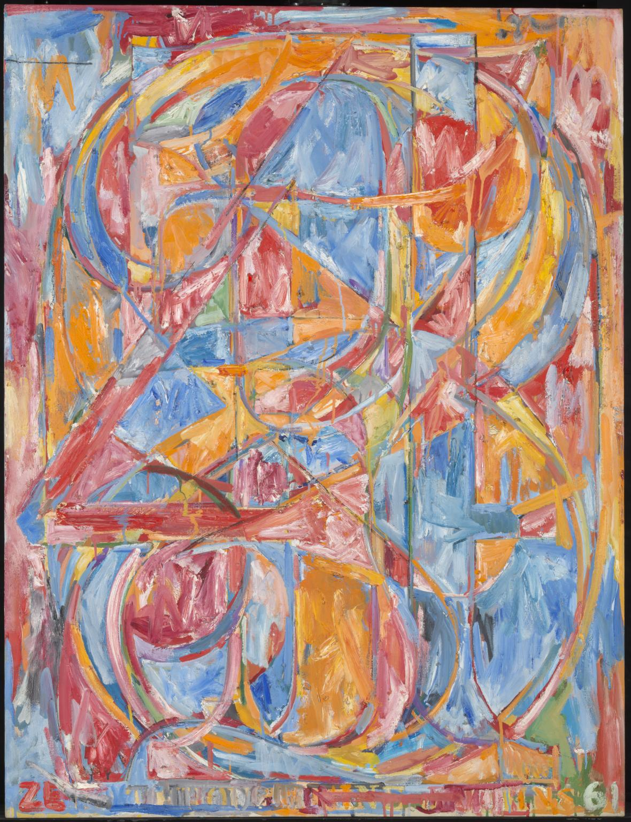

This painting is called “0 through 9”, as he is trying to paint all the numbers from 0 to 9 on one canvas. He uses a variety of colours to illustrate this and uses the Op Art structure again to allow to user to focus on a number they are thinking of while ignoring the other numbers.

There are a lot of different brush techniques and textures used here, and outlining those numbers are usually highlighted in white/bright strokes. Overlaying the image with fine white brush strokes may resemble this image. A number stamp may also be used.

## Jasper Johns: FLAG

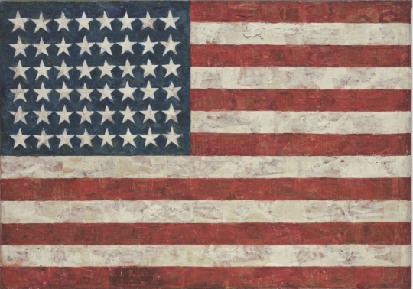

This painting is unique in a way where if you look closely, you can see a transparent image planted on the American flag. The painting is simple, using some textures similar to his dartboard painting, where he makes his colours look old and rusty.

This inspires us to again, use an opacity tool to recreate this effect overlaying dark grey colours onto the flag image.

## 

## Jasper Johns: FLAG on orange field

As you may have noticed, Johns loves to use objects such as flags as base and works off that as inspiration. Here, he paints the background orange.

This effect can be replicated by using orange strokes to fill the background, then using white opacity strokes to create that chalky texture.

## sketch.io sketchpad

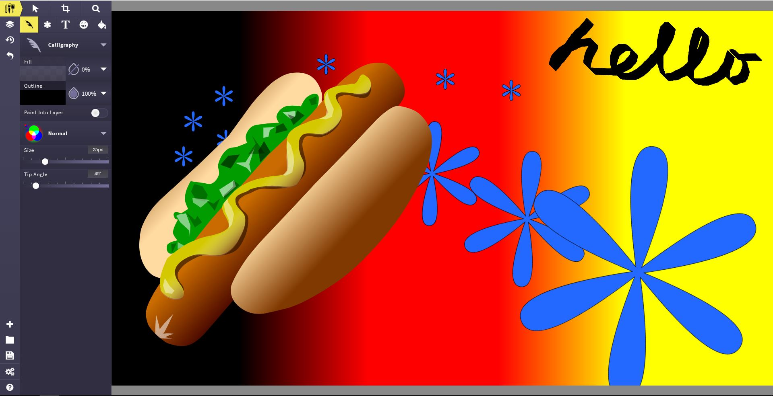

This sketchpad has the side bar on the left. The user interface looks somewhat hard to use and may not be suitable for the older audience. The buttons are very small, and considering touch input, this is a bad design.

Having too many buttons, may also distract the user into figuring out how the kiosk works instead of painting Jasper Johns art.

## kleki.com sketchpad

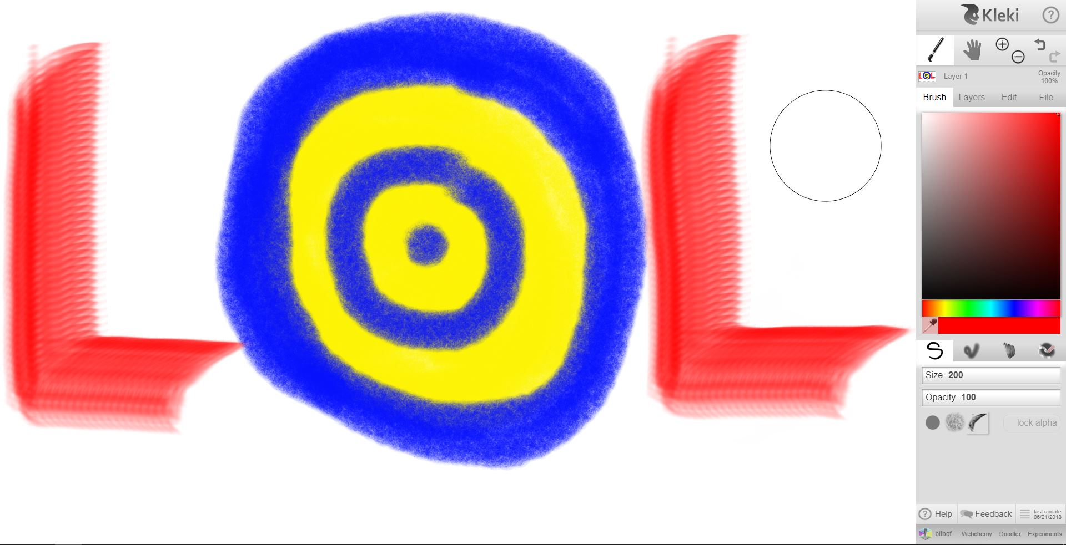

However, this sketchpad looks very suitable for all audiences. The toolbar is on the right-hand side and allows you to choose a variety of colours and textures. Though, this sketchpad does not look attractive to the eye.

Everything looks compressed, forced and is not spaced out to appeal the eye.

## galactic.ink sketchpad

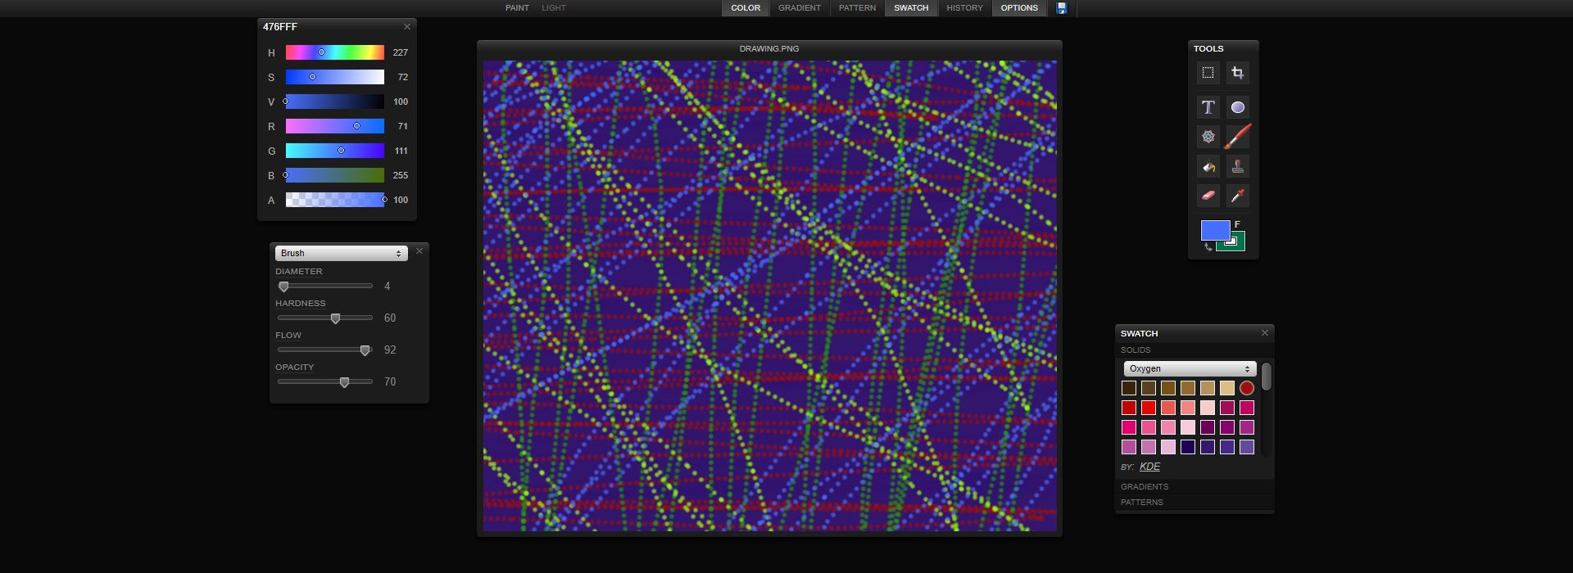

Galactic.ink sketchpad shows a variety of tools to use as a user, even including the stamp function which we may use in our kiosk app. This setup is simple yet easy to control your brush stroke with textures using the brush tool. It has the luxury of spreading tools across your screen desktop screen. However, the sacrifice of the canvas size may be something we may want to consider.

## ms paint sketchpad

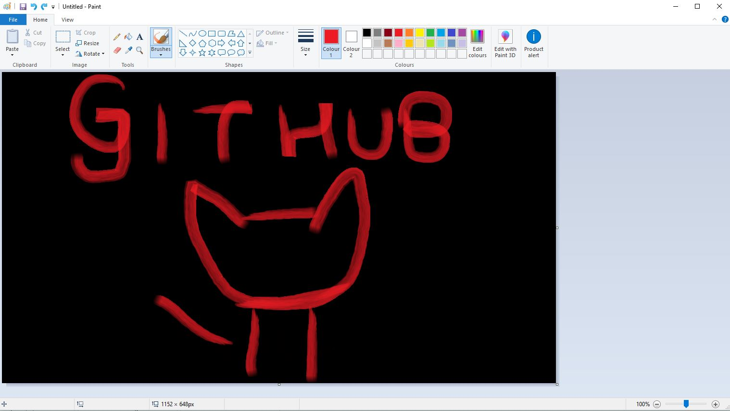

This sketch pad is the most basic sketch tool and is simple to use which can acts as a standard for a good drawing kiosk. For many unexperienced users who has not used a sketchpad, this would be a simple and easy learning experience without requiring a tutorial. The base template in having the tools on the top hand side is very clean and effective.

## LINODE.io

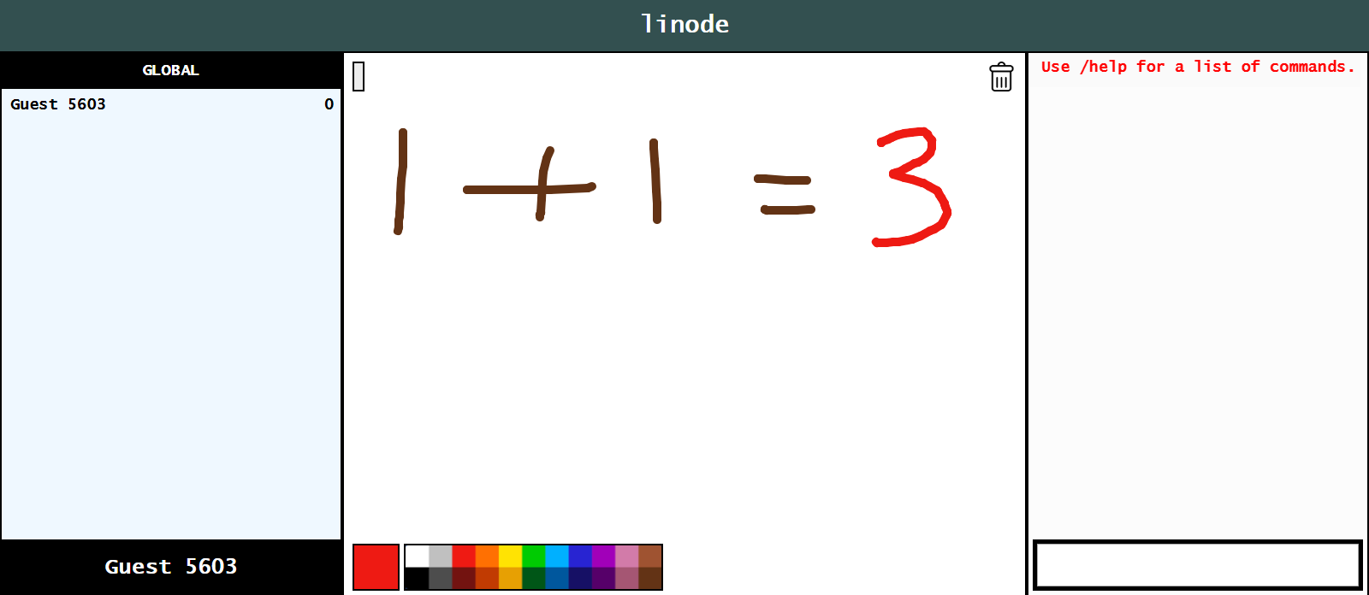

In contrast to the sketchpad above, this sketchpad has the tool bar on the bottom side of the screen. When using touchscreen, both feels very natural and does not show any limitations. But, you could argue that the with the toolbar on top, you are covering your painting every time you click one of the tools and as a result, may accidentally touch on the screen.

Other than that, having your tool bar on the bottom/top side shows no significant effect.

## Cosketch

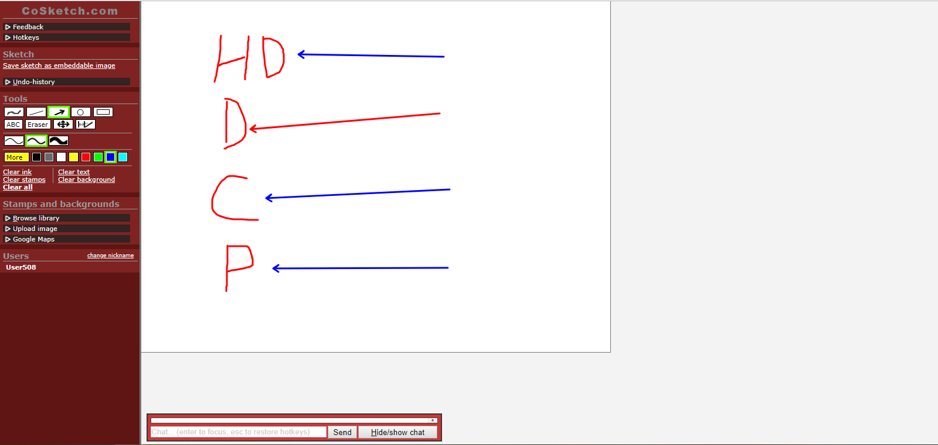

Cosketch is very easy to use. There are a lot of text that is clear to the human eye. This sketchpad also has functionality such as hotkeys which allow you access a tool upon press and upload images/use google maps.

Although this is very handy and useful, it may not be suitable for touch screen users as the hotkey function will be useless. The scope of the functionality may also be a bit too extreme.

## Literally canvas

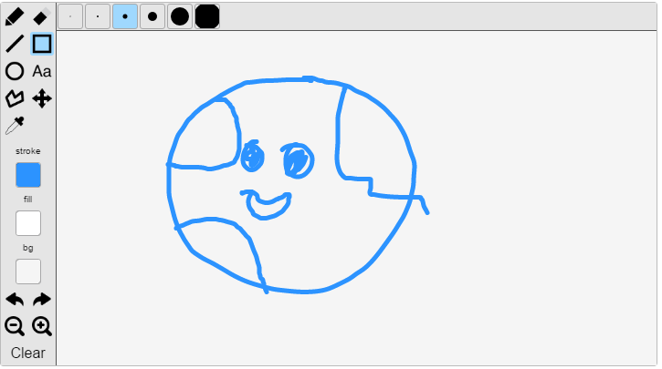

This drawing widget is something we would like to implement. The icons give an attractive look on what they are used for. But, upon testing it out, it felt more comfortable to reach when the toolbar was on the top/bottom of the screen. I think this is because, it takes more effort dragging your hand across to the left-hand side, if you are right handed.

Having the tool bar on top or bottom will provide equality to both right and left hand dominant users.

# Technical research

# Drawing tools

## Colour

Instead of selecting a fixed number of colours, we will provide a colour wheel which can generate a variety of colour shades for users to pick from. This will support both young and old users, as this is a common colour tool known in most applications, such as Microsoft Word.

We will also try to incorporate this element with many tools listed below, so it can change colours to shapes and text, instead of just the brush tool.

Users would use this tool if they would want to change colour.

## brush size

Like the colour tool, we didn’t want to limit the fixed brush size and thus, made a thickness slider which below shows the size of your brush. This is extremely friendly for touch screen apps and the user can set their brush thickness to whatever size they desire at an accurate fashion.

Similar to the colour tool, this will also be compatible with the stamps along with the different styles of brushes.

Users would use this tool if they would want to change their size of the brush for precise and detail.

# ADDITIONAL DRAWING TOOLS

## Opacity

To create an opacity effect, we can add a global alpha value to the brush stroke.

1.0 = Opaque, 0.0 = Transparent.

To make it simple and effect driven for users, we will have a slider indicating the opacity percentage of your current brush.

We didn’t think allowing the user to input the percentage number will be necessary, as the app is based on touchscreen events, it is not convenient to input text.

Users would use this tool on op art as well as painting jasper johns number paintings, as they require a lot of overlay textures.

## Brushes

We will implement a different variety of brushes due to Jasper Johns not having one unique style. We will cater brushes that helps create detail in targets, flags, maps and numbers.

A drop-down box will be shown below the brush tool once it has been clicked. Selecting another brush will replace the brush tool icon. We have decided to use this combined effect as replacing the brushes with the default brush does not distract nor confuse the user in anyway, and instead reminds the user what brush they are currently using.

This link was used as inspiration:

<http://perfectionkills.com/exploring-canvas-drawing-techniques/>

Users would use this tool to apply detail to their painting in conjunction with the brush size tool. This can be applied to all of jasper john’s paintings

## Drawing Geometric Shapes

As most of his paintings requires an object as a base, using shapes to create the object is an awesome feature for users to quickly draw on a perfect circle or rectangle. Applying extra functionality such as rotating the shapes, might be cumbersome when using a touch screen device.

This tool will only display the outline of the shapes and will not not automatically generate fill in the shapes. We felt this was important in Jasper Johns paintings as he doesn’t fill his shapes with opaque colours at all, allowing the user to colour the shape in with our texture brushes with opacity.

Users would use this tool to create the outline of Jasper Johns dartboards and flags. The shapes available will be circles, rectangles, squares and stars. The rectangle shape will be fixed, as it is mainly used for creating flags.

## Letters and Numbers as Stamps

Jasper Johns love to use numbers and letters in his paintings and allowing the user to accurately stamp on them instead of inputting or drawing it on, is a cool feature for the experience of the users. Jasper Johns uses a stencil look outline for his text, so having the user manually draw this style accurately will be a lot of hard work.

Users would use this tool for printing on text and numbers on your paintings. The font will be consistent and thus, forming a word using those letters would create a natural effect.

# Wireframe prototype

**Stamp tool**

Drops down 4 different stamps.

* Numbers from 0-9
* Letters from A-Z
* Shapes such as squares, circles

**Brush tool**

Drops down 4 different brushes which replaces icon upon selection.

* Default paint brush
* Vertical Roller
* Horizontal Roller
* Spray
* Highlighter

**Opacity tool**

Drops down a slider which displays opacity %

**Size tool**

Drops down a slider for the brush size.

**Erase tool**

Erase using current brush and size.

**Colour tool**

Drops down a colour pallet.

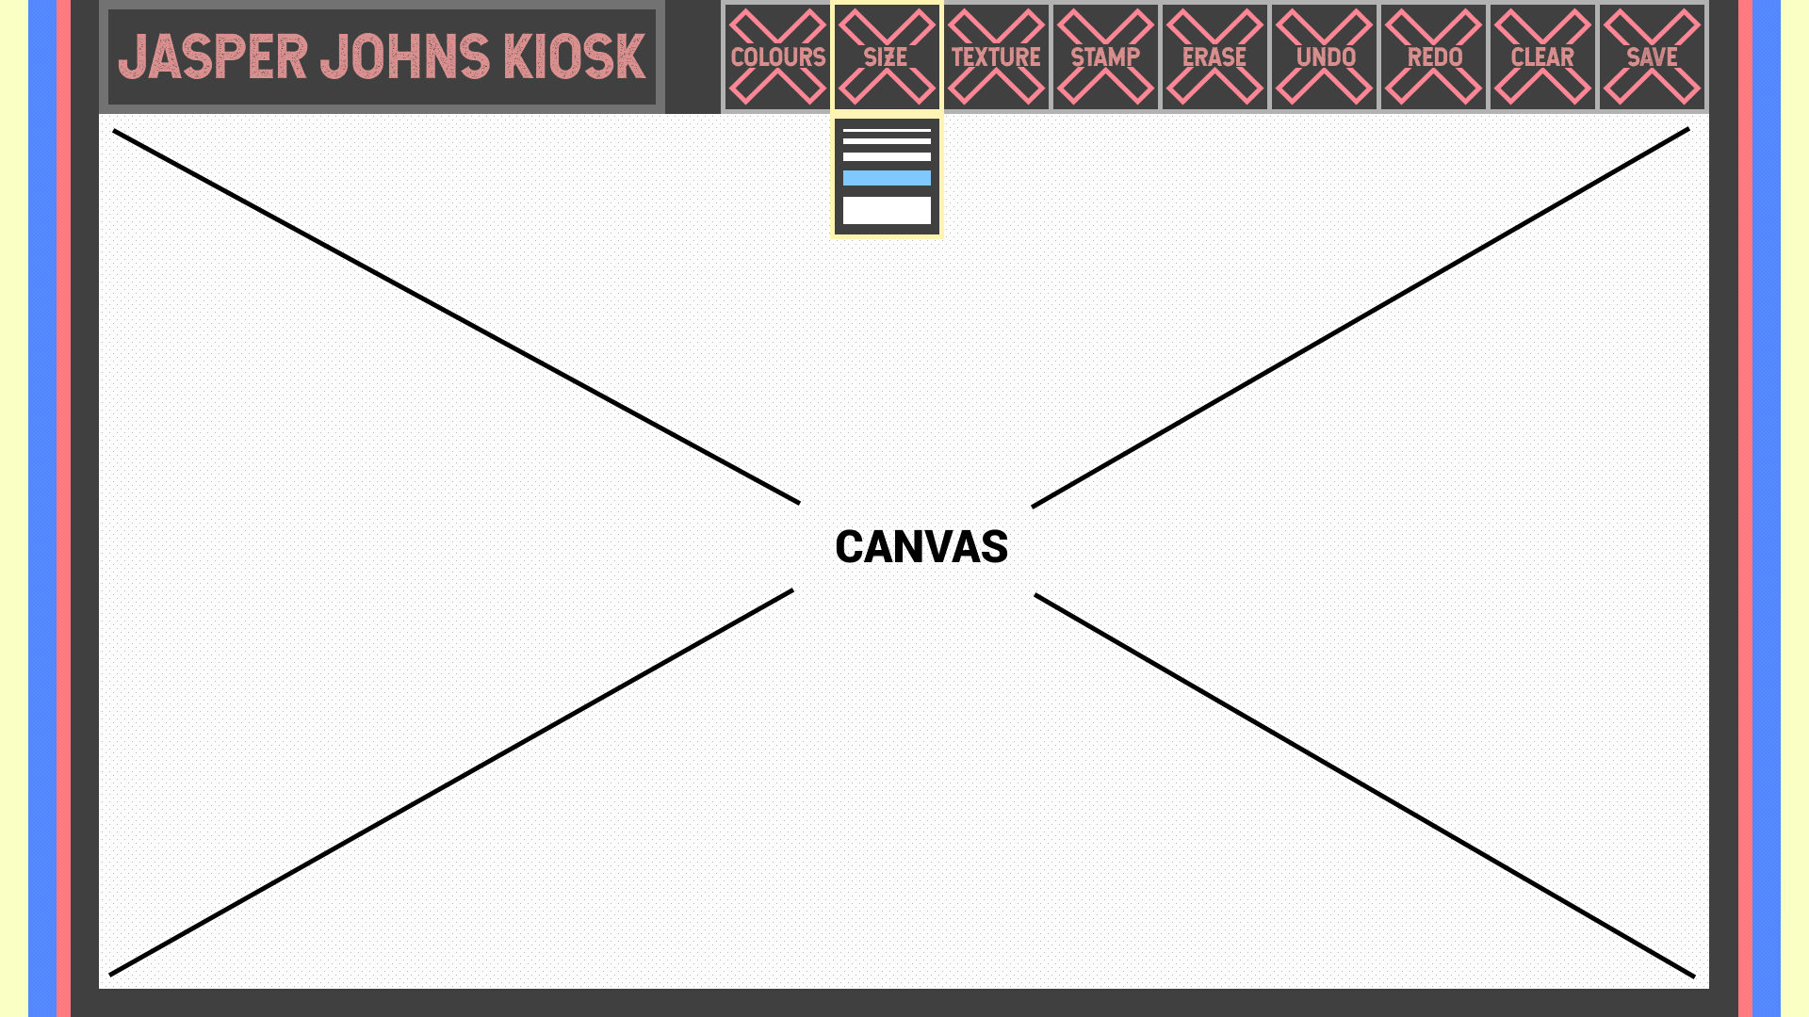

**Canvas**

Able to draw on it.

**Save tool**

Saves the entire canvas and downloads in a PNG format.

**Clear tool**

Clears entire canvas. Will ask permission before doing so.

**Redo/Undo tool**

Allows user to redo and undo changes per ‘click’ event.

# References – DOCUMENTATION

### Images

<https://www.pexels.com/photo/woman-wearing-pink-floral-sleeveless-romper-sitting-on-gray-concrete-holding-earth-globe-638696/>

<https://www.tate.org.uk/art/artists/jasper-johns-1365>

<https://www.moma.org/collection/works/78393>

<https://www.moma.org/collection/works/79372>

<https://www.abebooks.co.uk/9780947564285/Cage-John-Cunningham-Merce-Johns-0947564284/plp>

<https://www.sfmoma.org/read/discussion-questions-jasper-johns-lands-end/>

<https://sketch.io/sketchpad/>

<http://kleki.com/>

<https://galactic.ink/sketchpad/>

<https://linode.herokuapp.com/apps/canvas/canvas.html>

<https://www.moma.org/collection/works/78805>

<https://www.tate.org.uk/research/publications/in-focus/dancers-on-a-plane/the-painting>

<http://cosketch.com/Rooms/xlgaecc>

<https://ourcodeworld.com/articles/read/117/top-5-best-sketchpads-and-manually-drawing-on-canvas-javascript-and-jquery-plugins>